Expressive Arts and Design  Outcomes –  Explore different materials freely, in order to develop their ideas about how to use them and what to make.  Develop their own ideas and then decide which materials to use to express them.  Use drawing to represent ideas like movement or loud noises.  Make imaginative and complex ‘small worlds’ with blocks and construction kits, such as a city with different buildings and a park.  Respond to what they have heard, expressing their thoughts and feelings.  Sing the pitch of a tone sung by another person (‘pitch match’).  Sing the melodic shape (moving melody, such as up and down, down and up) of familiar songs  Daily -  Role play area/Small World area/ Construction small and large-. Cut and stick resources, ribbon, feathers, pipe cleaners, tape/masking tape, tissue paper.  Children to take pictures of their models and creations.  Singing and dancing- Wake up shake up, Go Noodle and outdoor music area | Summer Term 1  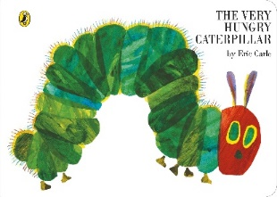  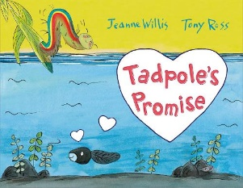  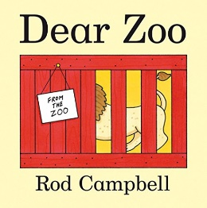  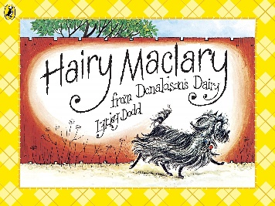  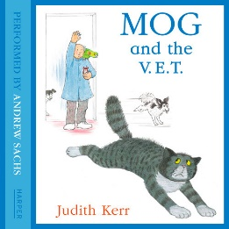 | Understanding the World  Outcomes –  I am beginning to make sense of my own life-story and my family’s history  I am developing a positive attitude about the differences between people.  I know that there are different countries in the world and can talk about the differences I have experienced or seen in photos.  I can care for growing plants.  I understand the key features of the life cycle of a plant and an animal  I can explore and talk about different forces I feel.  I can talk about the differences between materials and changes I notice.
History:
Learn about the timeline of our pets and how, with the passing of time, they have grown and got older e.g. kittens to cats and puppies to dogs.
Geography:
Animals from around the world - using the internet and books, we will learn about animal habitats and where they are in the world.

Design & Technology: Using art by Jeff Koons as inspiration, make junk model animals using clay and tools.

Art: Invite children to draw their favourite animals from our Mobile Zoo visit.
Focus artist: Jeff Koons (DT)

RE: Good News: Passing on the good news of Jesus.
Friends: Friends of Jesus
Music: Share the WAGOLL with the children and let them know that we will be learning how to care for animals then writing our own song together!
 |  | Science: Lifecycles of frogs – observe as our frogs continue to grow and change, create drawings of the life cycle and label them.
EAD Enhanced Provision –
Life cycle drawing
Animal painitng
Feathers, eyes, lollipop sticks and pictures from Dear Zoo to make animals and crates for them.
Paper plate animals – spiral snakes and lions
Photos of the children to turn themselves into their favourite animals e.g.

 |  | Computing: Using technology to help us - Model getting stuck on a feature when drawing our favourite animals, use the internet to find a picture of a dog to help me. Discuss how books, internet and real animals can make our drawing better. Children to draw pictures of their favourite animals on iPads.
 |  | Forest Schools- Outdoor learning- Exploring the outdoor area and forest school rules. See separate planning.
Enhanced Provision -
Look at the features of animals, notice details and learn the reasons for them, then use this knowledge to enhance their drawings e.g. monkeys have long tails to help them move through the trees.
Stuffed animals and leaflets in the vets role play to support the understanding of how to care for animals.
Photos of habitats from around the world for children to recreate in the small world area.
Clipboards and writing frames for children to draw their own frog lifecycle.
Magnifying glasses and bug collection tubs outdoor

Maths  Outcomes –  I can quickly recall up to 3 objects, without having to count them individually (‘subitising’).  I can say one number for each item in order: 1,2,3,4,5.  I can link numerals and amounts: for example, showing the right number of objects to match the numeral, up to 5  I can solve real world mathematical problems with numbers up to 5  I can recite numbers to 10  I can talk about and explore 2D and 3D shapes (for example, circles, rectangles, triangles and cuboids) using informal and mathematical language: ‘sides’, ‘corners’; ‘straight’, ‘flat’, ‘round’.  I can make comparisons between objects relating to size, length, weight and capacity  I can extend and create ABAB patterns – stick, leaf, stick, leaf.  I can notice and correct an error in a repeating pattern.  I can discuss routes and locations, using words like ‘in front of’ and ‘behind’  Daily Maths Meeting - Days of the week, months of the year, counting to the date, number songs.  Specific activities (Master the Curriculum teaching) –  As part of our learning about Dear Zoo/animals, make a pictogram together to find out our class’ favourite animal.  Using nursery rhymes, children will begin to explore sequencing. They will be introduced to the vocabulary related to time, such as first, next, then, after that, finally  Using teddy bears, children will begin to explore the vocabulary related to the position of objects. Most children should be able to understand position through words alone, without any gesture or pointing.  Using animals, children will begin to compare quantities  Children will be encouraged to talk about and explore 2D shapes using informal language. They will also begin to explore mathematical language, such as sides, corners, straight, flat and round.  Maths enhanced provision –  frames to make own pictograms using stamps  nursery rhyme cards for sequencing  positional language cards for children to copy in small world area  separator screen in the water area to compare objects either side.  2D shape tessalation mats. | Literacy  Outcomes –  I know print can have different purposes  I can name the different parts of a book, including front cover, back cover, title, author, page  I can engage in extended conversations about stories, learning new vocabulary  I can tell a story to friends  I can talk about events, the setting and characters in books  I can recognise my own name.  I can recognize some RWI sounds and use them in Word Time.  I can use print and letter knowledge in my early writing. For example: writing a pretend shopping list that starts at the top of the page; write ‘m’ for mummy  I can tell an adult what I have drawn or painted  I can write my first name independently so it is recognisable to others, using a variety of media  I can use print and letter knowledge in my early writing. For example: writing a pretend shopping list that starts at the top of the page; write ‘m’ for mummy  I can tell an adult what I have drawn or painted  I can write my first name independently so it is recognisable to others, using a variety of media  Daily Literacy - Name writing, mark making, self registration for name recognition. RWI teaching – 2 groups.  Specific activities – Write a list of important things to remember when caring for a chosen animal. Read the story of Dear Zoo and together, encouraging children to join in with repeated refrains. Write the lyrics to our song remembering all that we have learnt about caring for animals.  Enhanced Provision –  Copies of focus books and non-fiction texts  Sequence the story using the cards.  Make your own book about a very hungry YOU! On Monday you eat… etc.  Dear Zoo writing frames and photos of animal visit for children to write/mark-make labels/captions  Nursery rhyme cards for sequencing and leaflets in the vets roleplay to read.  Hungry caterpillar cards for sequencing and coronation writing frames & small world.  Life cycle drawing frames and question writing frames based on our virtual ‘bring a pet to school’ session.  Make get well soon cards for the animals in the vets and add more writing opportunities to the vets role play – make your own leaflet, book appointments with cards, etc

Communication and Language  Outcomes –  I can listen to longer stories and recall much of what happens  I can remember, join in with and retell familiar rhymes and stories  I can understand ‘why’ questions, like: ‘Why do you think the caterpillar got so fat?’  I can turn my head and focus on adults and friends, as I speak and play, responding to comments appropriately  I can follow a familiar two part instruction e.g. fetch your coat and sit on the carpet  I can use longer sentences of at least 6 words  I am beginning to join phrases with words, including of, so, but, because  I can attempt to use multisyllabic words  I can speak with clarity, using future and past tense (sometimes with errors).  I can use talk in my play to organise an activity with others e.g. ‘Let’s go on a bus…you sit there… I’ll be the driver.  I am able to use pronouns (he, she, him) and plurals correctly  Daily - Observing communication, listening and understanding in all areas of learning.  Specific activities – Children to share pictures and videos of their pets in a show and tell format.  Poetry Basket – Popcorn, Pancakes, can Build a Snowman, A Little Seed, Mrs Bluebird  C&L Enhanced Provision –  Vets role play to introduce new vocabulary  Nursery rhyme stories and cards for children to independently sing and recite.  Photos of children’s pets in the home corner to support discussions  Tadpoles & magnifying glases  Grow butterflies.  Food tasting session with foods from the story with blindfolds.  Make a small world of the story.  Layout some objects from the story then hide one, which one is  missing? | Physical Development  Outcomes –  I can use one-handed tools and equipment, including rollers, hole punch  I am beginning to cut along a continuous line, using one hand  I can hold a pencil near the point between thumb and two fingers, no longer using whole-hand grasp. I may need reminders  I can copy some letters from my name  I can use tweezers and pincers to move objects from place to another  I can show preference for a dominant hand  Skip, hop, stand on one leg, and hold a pose for a game.  Go up steps and stairs or climb up apparatus using alternate feet.  Collaborate with others to manage large items, such as moving a long plank safely.  I can skip, hop, stand on one leg and hold a pose for a game like musical statues.  I am increasingly able to use and remember sequences and patterns of movements, which are related to music and rhythm.  I can catch a large ball  I can move freely and with pleasure and confidence in a range of ways, including running skilfully and negotiate space successfully.  I am beginning to use my arms and ribbons to draw circles in a figure of 8  I can ride a balance bike with good control whilst running or gliding | PSED  Outcomes –  I am aware that I am part of Easby class and have a shared responsibility to follow our class rules.  I can follow the rules, understanding why they are important  I can decide what I want to achieve when playing eg, I want to build a rocket  I understand that equipment and tools have to be used safely.  I can begin to accept the needs of others and can take turns and share resources, sometimes with support from others.  I can usually tolerate delay when my needs are not immediately met and understand that my wishes may not always be met.  I can usually adapt my behaviour to different events, social situations and changes in routine  I am becoming more confident with unfamiliar people in familiar settings  I can play with one or more other children, extending and elaborating play ideas e.g. building up a role-play activity with other children.  I can demonstrate friendly behaviour, initiating conversations and forming good relationships with peers and familiar adults.  Daily – intervention given to each child in their play and when navigating . Mindfulness- Yoga- Super Yoga/Wake up Shake up. Feelings discussions and social stories.  PSED Enhanced Provision –  Talk about feelings in the book, how might the caterpillar feel when he comes out of the egg? When in the cocoon and when comes out again? Say I am curious, how would you feel if you were the caterpillar?  Circle time – feelings of having no food  Look at things from the tadpole/caterpillar’s point of view  Vets role play to support care and compassion  helping one another to put on their helmets before riding the bikes outside.  support to play collaboratively and extend play ideas when in the vets roleplay and construction.  Children to be supported to feel comfortable when sharing the pictures and videos of their pets.  Visiting the zoo board game, introduced to children in small groups to support turn taking and patience.
PE: Unit 1 - Games
I am beginning to explore a range of ball skills.
I am beginning to negotiate space safely.
I am beginning to take turns with others.
I am beginning to understand how I feel in different situations.
I can explore movement skills.
I follow instructions with support.
I play games honestly guided by the rules with support.
PD Enhanced Provision –
Use playdough to retell the story as you watch it, make an egg,
lead, tiny caterpillar, big caterpillar, fruit, cocoon and butterfly.
Hole punching leaves.
Sort healthy and unhealthy foods from the story.
Threading leaves.
Move like a caterpillar, like you are in a cocoon and like you are a
butterfly. Use fast and slow music.
Cutting Skills, fine motor skills- cutters, play dough making, balance bikes, nuts and bolts, threading beads patterns. Large wooden blocks, obstacle courses, carrying blocks safely.
Playdough.
hole punch and pva glue added to creative area
Junk modelling and clay animals
Frog drawing with chunky pencils
scissors and snip strips in Montessori area.

