Expressive Arts and Design  Outcomes –  Draw with increasing complexity and detail, such as representing a face with a circle and including details.  Explore colour and colour mixing.  Show different emotions in their drawings and paintings, like happiness, sadness, fear etc.  Begin to develop complex stories using small world equipment like animal sets, dolls and dolls houses etc.  Create their own songs, or improvise a song around one they know.  Play instruments with increasing control to express their feelings and ideas.  Daily -  Role play area/Small World area/ Construction small and large-. Cut and stick resources, ribbon, feathers, pipe cleaners, tape/masking tape, tissue paper.  Children to take pictures of their models and creations.  Singing and dancing- Go Noodle, dough disco, outdoor music area, instruments and song sticks | Spring Term 1  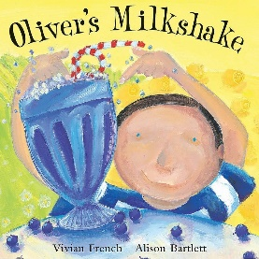  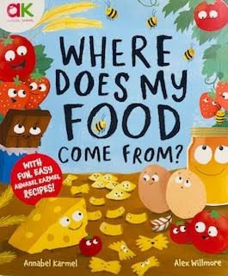  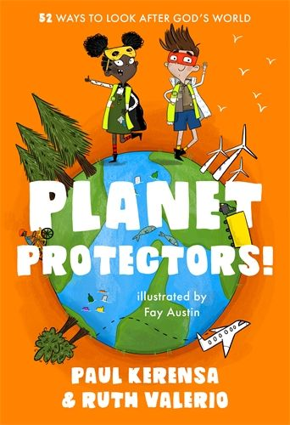  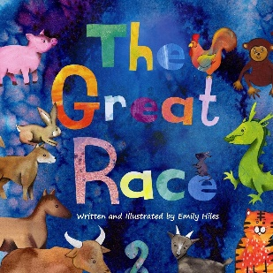  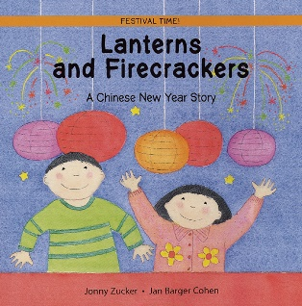 | Understanding the World  Outcomes –  I can remember and talk about significant events in my own experience  I can see my new friends have similarities and differences that connect them to, and distinguish them from, others. E.g. hair colour, gender  I can show interest in different occupations  Use all their senses in hands on exploration of natural materials.  I can explore collections of materials with similar and/or different properties.  I show interest when planting seeds  I am beginning to understand the need to respect and care for the natural environment and all living things
 |  | History: Remember and talk about our own Christmas and New Year experiences. Talk about nursery rhymes from long ago – introduce language of before, old, past, ago.
Geography:
Look at china on the world map and discuss how we could travel there. Introduce vocab of far, close, travel, transport etc.
Planet protectors expedition
Design & Technology: Can you design and make a milkshake to share with your grownup (Final product/presentation)

Art: Kindah Khalidy inspired art work – using oil pastels
RE: Celebrating: People celebrate in Church.
Islam: Prayer Mats
Music: Introduce children to Chinese dragon/lion dancing, experiment with movement and material to the music.
Science: Fruit exploration with 5 senses to find out our favourites to go in our milkshakes.
Seasonal changes – winter
Habitats
Recycling & protecting our planet – making our own paper from used blue paper towers
EAD Enhanced Provision –
Designing our own milkshake for Oliver to try
Printing with fruit/veg and paint
Junk modelling to recycle – making our own binoculars to help us spot the rubbish on our litter pick – make our own masks and capes to be Planet Protectors
Fruit/veg collages with colour sorting

CNY
Invite children to explore colour and colour mixing to paint Chinese dragon pictures. Provide red and yellow paint for children to use to paint dragon pictures and explore what happens as the colours mix.
Fill buckets with water and gold eco-friendly glitter, and add large paintbrushes to them for the children to paint ‘sparkly’ pictures on the outdoor walls or floor.
Provide empty packaging for children to use to make Chinese dragons. Cardboard tubes and boxes could be provided along with tissue paper, paint and shiny paper.
Provide lots of red, gold and yellow materials and objects for children to use to create transient art.
Add red paper outside, a collection of sticks and sticky tape for the children to create their own dragon puppets.

Computing: Introduction of remotes and velcro screens on the home corner TV to ‘change the channels’ and discuss.
Introduce the vocabulary of computer, iPad, laptop, tablet, technology, internet, website, apps. Children to take photos for class display. Video each other sharing a recipe.
 |  | Forest Schools- Outdoor learning- Exploring the outdoor area and forest school rules. See separate planning.
Enhanced Provision -
Sorting healthy/treat foods
Sorting and categorising fruit/veg
Creating habitats for winter animals outside
Writing on our homemade paper
Explore weather - Use a variety of objects with holes to create raindrops and showers, pour water down different tubes and explore speed
Which container holds the most water to help Oliver as he grows his veg/fruit
Sorting materials

Maths  Outcomes –  I can show ‘finger numbers’ up to 5.  I can experiment with my own symbols and marks as well as numerals  I know that the last number reached when counting a small set of objects tells you how many there are in total (‘cardinal principle’).  Daily Maths Meeting - Days of the week, months of the year, counting to 5, number songs.  Specific activities –  - Learn number songs about 3, 4, 5.  - Show, throw, grow 3, 4, 5 fingers  - Teach subitising with dots, objects, counters, etc.  - Teach subitising by looking for groups related to numbers we already know e.g. 2 and 1 more dots is 3.  - Introduce numerals 3, 4, 5 and learn to recognise/write them.  - Number 4 1:1 counting  - Squares/rectangles  - Composition of 4  - Number 5 1:1 counting  - Pentagon  - Composition of 5  Maths enhanced provision –  Water  • Pebbles numbered 1 – 5 at the bottom of the water, children to scoop them up and place that many animals on the ‘iceberg’  - Small world animal set and icebergs made from polystyrene. Children to balance 3 animals on each ‘iceberg’  - Freeze the numerals in ice cubes. Children to free the number from inside the ice cube  Creative area/Tuff tray  • Playdough ice-cream scoops. Provide children with bowls and playdough of different colours.  • Triangle sponges to create pictures.  Outdoor area  • Number 3 Hunt – Children to find images that show 3. Encourage them to mark off the corresponding sheet with 1 ‘tally/ mark’ showing that they have found it.  • Children to find items that can be found outside, such as 3 rocks, 3 flowers, 3 bikes – use muffin trays for children to fill with 3 items.  • Obstacle course with 3 of each item such as 3 boxes as a tunnel to go through, 3 hoops, 3 benches, 3 mats to jump on.  • Have a bucket or hoop and 3 bean bags for children to throw. How many go in? How many are outside the hoop.  Sand Area  • Bury different types of triangles, squares, pentagons in the sand. Children to find and then make imprints, discussing the sides they can see.  • Use gold coins and mark with the numeral 3. Children to dig them up and collect them in a treasure chest.  • Children to count out 3 coins in to treasure chests  Music Area  • Children to have 3 different instruments. Can they make a rhythm with the instruments?  Role Play  • Use puppets or small world characters for The Three Little Pigs, Three Billy Goat Gruffs and Golidlocks and The Three Bears.  Maths Area  • dice and simple boardgames.  Book list  • Three Little Pigs  • Three Billy Goat Gruffs  • Golidlocks and the Three Bears  • Roald Dahl’s 123  • It’s not easy being Number Three – Drew Dernavich | Literacy  Outcomes –  I can count or clap syllables in a word  I can make suggestions about what might happen next in a story  I know that print carries meaning and is read left to right, top to bottom  I can identify and suggest rhymes  I can identify letters from my own name in other words  I can recognize some RWI sounds  I can imitate an adult writing. E.G. a shopping list or card  I can start to write identifiable shapes and letters.  Daily Literacy - Name writing, mark making, self registration for name recognition.  Specific activities –  - Writing ingredients shopping list  - Writing recipes of our favourite milkshakes  - Mark making with fruits/veg – our names  - Provide puppets or costumes and objects from the story and encourage children to play with these items, recalling the story if they can. You could extend the props you give to explore the other stories within this book.  - Find out about the characters in the story by reading further tales and listening to nursery rhymes together.  - Discuss favourite nursery rhymes.  - Sing, say and re-enact favourite rhymes and songs  - Read and respond to stories about nursery rhyme characters.  - Change the rhyming words in various rhymes to change the meaning.  - Sound hunts, finding objects/ pictures that sound the same.  - Sequence pictures of rhymes  Enhanced Provision -  Writing ingredients shopping list  Writing recipes of our favourite milkshakes  Mark making with fruits/veg – our names  Letter to Oliver to say thank you for the milkshake recipe  Shopping Lists  In a large activity tray, set up a small world version of the Chinese New Year story using blue material for the river and Small World Characters – children to write labels for the characters  Place a variety of small world animals outside, such as an owl, a lion and a polar bear. The children can make up a new story about different animals trying to cross a river (the water tray).

Communication and Language  Outcomes –  I can concentrate for slightly longer periods, including 8 minutes during a carpet activity  I can focus on adults as they read or sing, responding with sounds and movements  I can respond appropriately to key vocabulary such as tidy, fetch, sit down, wash hands  I can identify characters in familiar books  I can follow a familiar story with props and pictures.  I am beginning to ask and respond to ‘why’ and ‘how’ questions  I am beginning to use sounds f, v, s, z, sh consistently  I can use words about things that interest me. E.g. Brontosaurus  I can give my point of view and debate when I disagree e.g. I like bananas…they are soft and yummy.  I can start a conversation with an adult or friend and take my turns to speak  Daily - Observing communication, listening and understanding in all areas of learning.  Specific activities -  Discuss favourite nursery rhymes.  Sing, say and re-enact favourite rhymes and songs  Read and respond to stories about nursery rhyme characters.  Change the rhyming words in various rhymes to change the meaning.  Sound hunts, finding objects/ pictures that sound the same.  Sequence pictures of Oliver’s milkshake  Retell the story’s key events  Share opinions on the milkshakes/flavours – I like & I don’t like… because…  Recount how we made our milkshakes and share with our grownups (Final product/presentation  Poetry Basket –  Popcorn  Pancakes  I can Build a Snowman  A Little Seed  Mrs Bluebird  C&L Enhanced Provision –  Role play area- Home Corner, writing opportunities in area with recipe books and healthy eating, mixing the ingredients to make something healthy.  Role play fruit/veg shop  Story sequencing cards  Small world farm | Physical Development  Outcomes –  I can use a palmer grasp when using writing media  I can use a static tripod or quadrupod grasp when modelled.  I can copy pre-handwriting patterns eg. zigzag lines, crisscross  I can pick up tiny objects using a fine pincer grasp.  I am beginning to use pincers, tweezers and threading equipment with some control  I can use tools with more control, creating with purpose. E.G. using a cutter to make a gingerbread man.  I can hold my scissors correctly when modelled by an adult and make snips in paper  I can kick a large ball.  I can respond and move to rhythm and music, moving safely in a smaller space. I am beginning to copy movements such as, hopping, jumping, skipping, and rolling  I am beginning to stand on one foot with support.  I can wave my arms or ribbons to make vertical lines and circles in the air. | PSED  Outcomes –  I know when to put an apron on.  I can go to the toilet independently.  I can tell adults when I am hungry or tired or when I want to rest or play.  I am beginning to learn about using equipment safely.  I can demonstrate a sense of self as an individual, e.g. want to do things independently, say “No” to adult  I have a growing ability to distract myself when upset, e.g. by engaging in a new play activity.  I can inhibit my own actions/behaviours most of the time, e.g. stop myself from doing something I should not do.  I seek out others to share experiences.  I can show affection and concern for my teachers and peers.  I am confident to talk to other children when playing together.  I can keep play going by responding to what others are saying or doing  Daily – intervention given to each child in their play. Mindfulness- Yoga- Super Yoga/Wake up Shake up. Feelings discussions and social stories.  PSED Enhanced Provision –  Emotions spoons and stories.  Set up the role-play area as a Chinese Restaurant. Provide bowls and spoons along with chopsticks, woks, ladles, etc. Decorate it using lots of lucky red decorations. Encourage the children to make other items to go into their restaurant, such as role-play food and decorations.  Provide these Chinese New Year Role-Play Masks to enable the children to role play the characters of the story.
PE: Dance Unit 1
In this unit, children will develop their expressive movement through the topic of 'everyday life'. Children explore space and how to use space safely. They explore travelling movements, shapes and balances. Children choose their own actions in response to a stimulus. They are given the opportunity to copy, repeat and remember actions. They are introduced to counting to help them keep in time with the music. They perform to others and begin to provide simple feedback.
I am beginning to negotiate space safely.
I am beginning to use and remember sequences and patterns of movements which are related to music and rhythm.
I am building my confidence to try new challenges and perform in front of others.
I can explore movement skills.
I follow instructions with support.
I show respect towards others.
Specific activities -
Using instruments to create music for nursery rhymes
Threading veg cut outs
Chopping fruit for milkshake
In a large activity tray, add a thin layer of red and yellow-coloured rice or sand and add a sprinkle of eco-friendly glitter. Provide chopsticks for children to use as mark-making tools.
Children could practise their fine motor skills by using clothes pegs to fasten paper lanterns along a washing line.
In a large activity tray, provide some lengths of wool as role-play noodles. Add some scissors, knives, forks and spoons. Challenge children to use the tools to explore the ‘noodles’.

PD Enhanced Provision –
Montessori AEL shelves to support fine motor development.
Cutting Skills, fine motor skills- cutters, play dough making, balance bikes, nuts and bolts, threading beads patterns. Large wooden blocks, obstacle courses, carrying blocks safely.
Outdoor obstacle course related to 3, 4, 5 (see maths section).
Playdough and blunt knives to practice fruit/veg chopping

