Maths  Outcomes –  I can show how numbers to 10 are made up using different models e.g. part whole, tens frame  I can recognise the numerals to 10 and match to quantity consistently  I can recognise quantities up to 5 without counting.  I can recall number bonds up to 5 and some to 10  I can match subtraction facts with number bonds  I can count beyond 20  I can compare quantities using greater/ more than, fewer/ less than, the same/ equal  I can show patterns in numbers to 10  I can say double facts  I can say which item is longer/shorter.  I can recall the days of the week.  Daily Maths Meeting - Days of the week, months of the year, yesterday, today, tomorrow, weather, subitising to 5, counting to 50 and back from 20, one more and one less, number bonds to 5 and 10.  Specific activities – See weekly plans for further indepth activities White Rose Maths  Building numbers beyond 10  Counting patterns/spatial reasoning  Adding more x2 weeks  Taking away x2 weeks  Doubles  Length & Height ,comparing height- taller/shorter, comparing length- longer/shorter- using non standard measures cubes.  Time- days of the week singing days of thr week song and put them in order.  Measuring time- how many things can you do in 10 seconds, 20 seconds, 30 seconds and 1 minuite. Relate time to hour o’clock linking to events in the day.  Maths enhanced provision –  Activities- number activities realted to weekly maths objectives, double sorting, building numbers to 20 using jigsaws, pattern spotting, tuff tray activtiies inside and outside, chalk numbers. |  | Literacy  Outcomes –  I can write most upper and lower case letters correctly  I can hold my pencil in a good tripod grip  I can write CVC words with sounds and letters I know  I can write tricky words  I can write simple sentences using capital letters and full stops.  I can read my own sentences  My teacher can read my sentences  Daily Literacy - Name writing and CVC word writing, mark making, letter formation, RWI sessions.  Specific activities -  Handa’s Surprise-  Retell the story in own words / Describe each animals  The Tiger who came to Tea-History links to old and new.  Acrostic Poem using TIGER  Non-fiction books about mini beasts and animals- Make a fact file about mini beasts.  Writie instructions for a sandwich linked to georgraphy and Paddington bear.  Non fiction writing, writing for a purpose in role play using phonetically plausible attempts at words, beginning to use finger spaces.  Using familiar texts as a model for writing own stories.  Form lower-case and capital letters correctly.  Rhyming words.  Learn about different pets and write a fact file about how to look after you pet- linked to topic.  Enhanced Provision -  Writing recipes, lists, alphabet jigsaws, CVC making words using jigsaws, stone letters to make words and match initial sounds, chalk writing outside, play dough letters, find letters in the sand, reading books linked to topic.
Communication and Language  Outcomes –  I can explain what I have read or has been read to me  I can retell simple stories  I can recall facts from information  I can say what I think might happen next  I can use new vocabulary throughout my play  I can match the letter and sound for all set 1 single sounds and some set 2 digraphs  I can match the letter and sound for at least 10 digraphs  I can read CVC words containing set 1 and some set 2 sounds  I can read CVC words containing known digraphs  I can read simple sentences and books matched to my phonics  I can read tricky words from set 1 and 2 confidently  Daily - Observing communication, listening and understanding in all areas of learning.  Specific activities -  RWI: Daily sessions varioud groups from Set 1 sounds, Set 2 sounds, red ditties.  Reading 1:1 books and additional flash card phonics throughout the day.  Poetry Basket – practice poems and record- performance poetry.  I have a Little Frog  Pitter Patter  The Fox  Monkey Babies  C&L Enhanced Provision –  Fruit and vegetable shop linked to healthy eating in Handa’s surprise- exchanging of money linked to maths.  Vets Role play liked to animals theme, bandages, booking forms, writing whats wrong with the animals, taking messages.  Exploration of other countries – dressing up in different costumes  Tea party- tiger who came to tea.  Handas surprise animated  Tiger who came to Tea film  Handas Surpise  The Pet Factor CBCC episodes  Topsey and Tim Vets  Molly and Mack- The vet  Vocabulary linked to text:  Delicious | 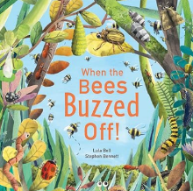  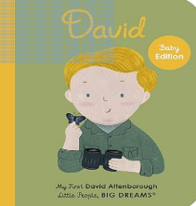  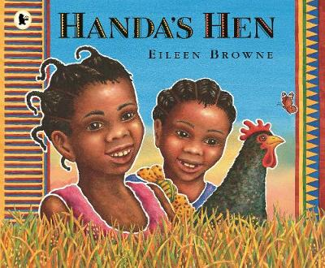  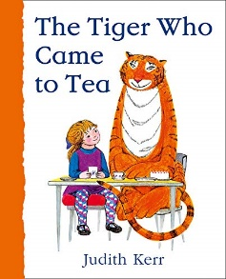  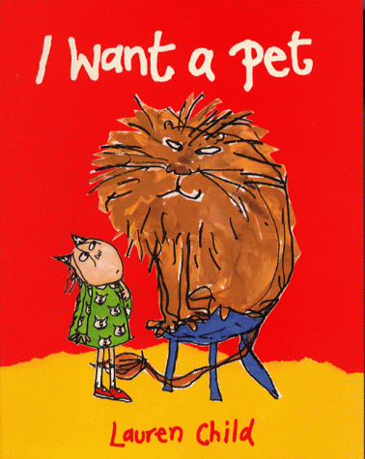  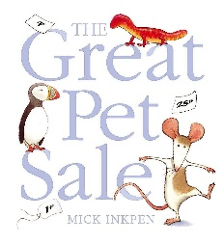  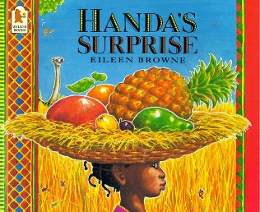 |  | PSED  Outcomes –  I can say how I and others are feeling  I can show my understanding of feelings by changing my behaviour  I can set myself goals  I can wait for my requests and needs to be met  I can listen to and respond to adults  I can follow instructions accurately (several ideas/ actions)  I can try new activities  I can show resilience and perseverance when things are difficult  I can explain and follow rules (in the classroom and around school)  I can show I know right from wrong by my behaviour  I can manage my own basic hygiene and personal needs e.g. toileting and dressing  I can explain healthy food  I can work with others in a group  I can play with others, take turns and share  I can form good relationships with the adults in the classroom and around school  I have lots of friends and positive friendships  I know what my own needs are and can share them  I am sensitive to the needs of others  Daily – Intervention given to each child in their play. Mindfulness- Yoga- Super Yoga/Wake up Shake up. Feelings discussions and social stories. Match meotion to name and explain how they feel.  Specfic activities  Ten Ten  Module 2 Unit 3  Session 2 Playing Online  Recap learning about the internet and reiterate that devices are not toys.  Read aloud the story Freddy Teddy Plays Online Discussing with children the questions that come up and what makes certain online choices safe and unsafe.  After the story further explore the concept of being safe and feeling safe and reveal Freddy Teddy’s top tips for staying safe online.  Children will engage with the story and activities and contribute to discussions about how to stay safe online. Children will learn about safe and unsafe situations online and that they can ask for help from special people.  Module 2 Unit 3 End of unit Assessment:  Children will complete the end of unit assessment activity and and misconceptions will be discussed.  Module 3 Created to live in a community  Unit 1  Religeous Understanding  Session 1 God Is Love.  Session 2 Loving God Loving Others.  End of Unit Assessment.  PSED Enhanced Provision –  Feelings table with different emotions, different books realted to emotions, self regulating sensory items- pop its, rainbows, colourful timers, social story books. Health and well being resources, growing resources linked to butterflies.

Expressive Arts and Design  Outcomes –  I can safely use tools e.g. scissors  I can explore using materials and techniques  I can design art/ a product thinking about colour, texture and function  I can explain what I have made  I can talk about how I made it  I can use props and materials when I am role playing familiar stories  I can adapt and recount narratives and stories with my friends and adults  I can invent my own stories  I can sing well known nursery rhymes  I can sing some familiar songs Performance of song  I can perform songs, rhymes, poems and stories alone and with others  I can try to move in time with music  Daily -  Role play area/Small World area/ Construction small and large-. Cut and stick resources, ribbon, feathers, pipe cleaners, tape/masking tape, tissue paper.  Children to take pictures of their models and creations.  Singing and dancing- Go Noodle and outdoor music area | Physical Development  Outcomes –  I can travel around space and obstacles safely  I can show strength, balance and co-ordination in movement  I can move in different ways- run, jump, skip, climb  I can hold a pencil effectively (tripod)  I can use a range of tools e.g. scissors  I can draw with accuracy  Daily: Cooperation games i.e. parachute games, Climbing – outdoor equipment., Help individual children to develop good personal hygiene. Provide regular reminders about thorough handwashing and toileting. Crates play- climbing, Provide a range of wheeled resources for children to balance, sit or ride on, or pull and push. Two-wheeled balance bikes and, skateboards, wheelbarrows, prams and carts are all good options
PE: Use skills learnt in sessions ot enhance outdoor provision.
Develop basic gymnastic skills. Children will explore basic movements creating shapes and balances, jumps and rolls. They will begin to develop an awareness of space and how to use it safely. They perform basic skills on both floor and apparatus. They copey, create and repeat sequences. They begin to understand using levels and directions when travelling and balancing.

Apparatus: Children will use apparatus to develop balance, hand eye co-ordination and jumping skills.
Sports day pereperation: Practise races and skills required for sports day.

PD Enhanced Provision –
Threading, cutting, weaving, playdough, Fine Motor activities.
Form letters correctly
Cut a shape out using scissors
Begin to draw diagonal lines, like in a triangle / Start to colour inside the lines of a picture
Draw pictures that are recognisable
Build things with smaller linking blocks, such as Duplo or Lego

Design & Technology
Exebition 1
Design and make a Puppet
Using pencil and coloured pencils, Children will choose their favourite animal or insect and create a design to make a paper bag puppet. Children will need to think about the different shapes, patterns and colours needed to create the different features of their animals as they will be making them using different patterned textured or coloured papers.

I remember the names of animals and can say what some of their features are.
I Use this knowledge to create a design of my favourite animal using a template.
I Can explain what shapes colours and patterns will be included for my animals features and what materials I might use when I make my puppet.

Week 2 and 3 children will create their puppet design using a veriety of media and materials.

I remember what animal I chose for my design and can talk about some of the features it has.
I use this knowledge to select my media and materials and can create a puppet which is inspired by my design and demonstrate how it movesusing my hands.
I can explain to an adult how I created my puppet and which media and materials I have used. I can say what I like about my puppet and what I like about my friends puppet.

Art: Expedition 3: Spirals: Access art Spirals Look at spirals in real life. Children will create spiral art using a veriety of media both indoors and outdoors using both gross and fine motor skills. Matise Snails: Children will learn about the artist Matise and create their own representation of snails using colourful paper pieces arranged in a spiral.

Music
Immersion week and Expedition 1
African Music link to Handas Surprise. listen to some African music focus on the different instruments they can hear introduce drums talk about rhythm. Group activity copy me rhythm game.
Rhythm
To experience and appreciate rhythm and rhyme and to develop awareness of rhythm and rhyme in speech
Objectives:
Makes up rhythms.
Taps out simple repeated rhythm
Explores and learns how sounds can be changed.
SEND: Explore the sounds that different instruments make, have a variety of different instruments and encourage the children to copy actions such as shake, scrape, tap, fast, slow ect. Can they copy a rhythm using 1 or 2 different instruments?
YolanDas band Jam
The Funky Elephant Dance all about Rythmn and Body Percussion.
Expedition 2
Come to the pet shop song:
Children will work together to create the song adding in instruments and creating different actions with their bodies and sounds with their voices children will work in groups to sing the song.
Expedition 3
Tiny Caterpillar on a leaf Music express
Focus Loud and quiet and Physical development. Add actions to the song, perform a dance to the song , Use instruments to make quiet music to match the words/actions in the song. Last section children recite words in the poem from quiet to loud.
EAD Enhanced Provision –
Animals masks to decorate, butterflies to study and draw, animal skin picture to copy and draw. Pictures of animals to paint.

Understanding the World
Outcomes –

I will begin to talk about how they feel when I have good news to share.
I will begin to say what they wonder about the joy good news brings.
I will begin to recognise the Pentecost story as a religious story.
I will begin to use and recognise some religious words such as Pentecost, Good News, alleluia, Easter, Holy Spirit.
I will begin to recognise that Christians are happy at Pentecost and go to church to celebrate the Good News.
I will begin to talk about how I feel when I hear the Good News.
I will begin to say what I wonder about Pentecost Day and the Holy Spirit.
I can talk about the lives of people I am familiar with
I can talk about the roles of people in society
I can give similarities and differences between the past and now
I can describe the school environment using what I know from
• Observation
• Discussion
• Stories/ non-fiction
• Maps
I can talk about religion and culture within my country (UK)
I can talk about what is the same and different in life in this country and in other countries
I can explore the natural world
I can make observations of animals and plants and use these observations to draw pictures
I can contrast the natural world around me with different environments
I can talk about some of the changes in the natural world (including seasons and changing states of matter)
Daily
Role play items- tv screen and remote, telephones, computers, calculators, books, weighing scales, science objects magnetics and magnifying glasses for inside and outside use, maps on wall.
Geography:

RE:
Growing
Continue the topic and write parts of the Easter story retelling in their own words.
Respond Booklet

Good News Pentacost
Explore: Class discussions about good news, draw a picture and write about a time you shared good news with someone and how it made them feel, to talk about how you think good news effects other people.
Reveal: • Make a Pentecost windmill- experience how the wind feels outside and what happens to the windmill, drama- Retell the story of Pentecost, discussions about Pentecost.
Class discussions about Pentecost, make a handprint Dove, recall the events of the Pentecost?
Complete Respond Booklet.

Friends:
Explore: Class discussions about friends- circle time who is your friend and what makes them a good friend.
Reveal: Talking about friends an their qualities and discuss what happens when friendships go wrong and what could they do? Draw a pictrure of your firend and list their qualities.
Jesus rule for friendships and what we can do to follow in Jesus’ footsteps, make a feiendship braclet for a friend, friendship hand print ring
Respond Booklet
Science: Understand the effects of changing seasons on the world around me- exploring in Forest School- Outdoor learning. Looking for signs of spring, what can you find in the outdoor environment. Weather focus rain.  Immersion Week: Introduce Big Question: How do we care for our wonderful world? Explain that we are going to focus on the Animals in our world and look at how and why we need to care for them. Create a focus Display all about Amazing Animals and David Attenborough which we will add to each week. We are going to learn about wild animals, Domestic animals and Insects and minibeasts.  Focus person: David Attenborough: Read the Little People big dreams book with David Attenborough. Show children a picture of David Attenborough and explain who he is and what he does to help everyone to care for our world. Tell the children that they can be environmentalists and Nature Detectives just like David is and that they could start by exploring the outdoors and by observing animals in their natural environment. The children will explore outdoors and observe the tadpoles that we have been caring for in class. Play the Little people big dreams Quiz about David Attenborough.  Frog Life cycles:  Observe what has happened since the tadpoles hatched out of the frogspawn and what will happen next. Complete a life cycle of a frog activity outdoors playing order game where children choose a picture and have to organise themselves in the correct life cycle order.  Expedition 1: Wild Animals  Look at animals in the wild from a veriety of books, online or in real life.  Children will learn about wild animals and their habitats and explore why some wild animals are endangered and how people can help to overcome this.  PZAZ Science R16 reception Biology Habitats  Pupils need to be able to describe the environment in which living things exist is called a habitat.  Pupils can name different types of habitats.  Pupils can associate some living things with a particular habitat.  Expedtion 2 : Pets and Animals who help us: See Pets overview what type of animals help people ? what type of jobs do they do? Look at fact books about animals who help us . Children will draw their favourite animal who helps us and give clues as to which animal it is and the job they do by writing sentences or labelling. Sentence stem.. I can help… connectives and I am a …  Expedition 3: Incredible Insects: Investigate with the children why minibeasts are an essential part of out eco system, Butterfly life cycle activity. Create a minibeast scavenger hunt card that they can use for grand finale. Children will select several different minibeasts to put onto their list they will use identification books to find their names and use these to support writing. Children can write clues about what habitat their minibeasts might be found in. Children will use real life pictures sourced from the internet to add to their lists. They will add tick boxes so they can mark when they have found their minibeasts.  Real life observation of caterpillars morphing into Butterflies.  Grand Finale: Invite parent to outdoor learning session so that they can use their mini beast scavenger hunt cards to carry out a minibeast hunt. | Pets Overview: Mobile Zoo Visit- After half term  All about Pets: Talk about own pets and why they are special, tally chart of pets they own or would like to own, drawing pictures of their own pet or a friends pet, write a sentence about why they are special.  How we can look after pets- Talk about what pets need to be healthy, vets role play, make a lead and tag for a pet- soft toys. Great Pet sale book linking to money and paying for the pet.  Pets from the past- look at similiarites and difference from pets in the past to now- what is different what is the same, how do we care for pets now?  Habitats of exotic animals and look at exotic pets/more unusal pets, what different care do these need compared to warm blooded animals, make a habitat for an animal, wormery.  Working animals- Talk about which animals help us to support those with disabilities and in the wider world-, police horses, dogs, relate to past and horses ploughing fields to now machinery, dective dog recognising smells and give children a range of smells to see how dogs detect things. Carrier pigions take messages- create a secret messge using invisable ink and transport it- what does it say?  Links to animals from all around the world Handas Surprise and their habitats, Small world animal sorting, matching fur to animal, painting, using instruments to be different animals, animal foot prints.  Endangered animals in the world, introduce endangered animals and think about the part humans play in this. Watch a video clip on habitats and endangered animals and find out ways to help.  Link weighing and capactity to animals feeding and drinking.
Computing: Use interactive whiteboard on daily baisis using top marks for maths and phonics games, purple mash for colouring and drawing pictures and learn how to save work in their own trays.
Use ipads to find information about pets.
Draw different pets on the ipads.
Use google Earth to show where we are in where Africa is.
Take pictures of models children have built and type a sentence about them.
Take pictures outside of the changing seasons and describe what they can see.
Use the Ipads inside and outside to capture different moments of play.

Labelling a plant using the Ipads, life cycle of a butterfly on the ipad and record the life cycle, taking pictures of nature using ipads outdoors to connect to art topic and colours, take the floor robots outside and make them go around an obstacle course,
My favourite fruit using 2Simple to complete asking other children and make a graph- save to folder.
Forest Schools- Outdoor learning- Exploring the outdoor area and forest school rules. See separate planning.
Enhanced Provision –
Life cycle resouirces and blocks to explore the life cycle of a butterfly and hen, books linked to life cycle, floor robots, gardening equipment outside, books relating to animals and pets.

